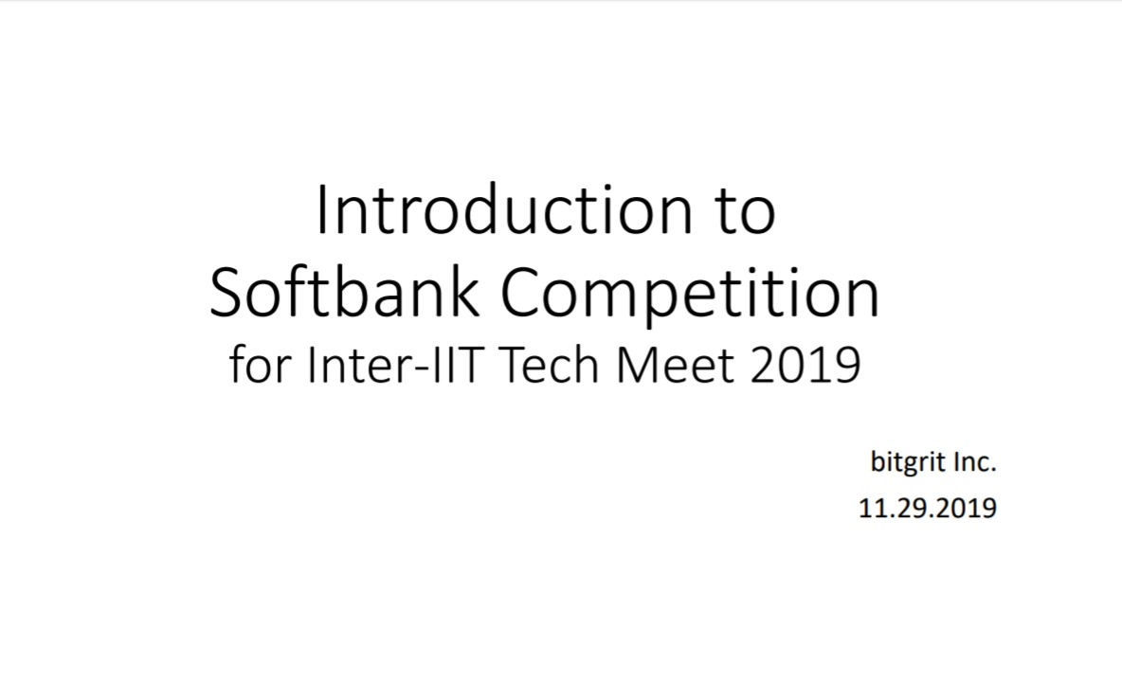
DESCRIPTION:
In the foreign exchange market, the smallest changes in international affairs and economics can have a huge effect on the conditions of a financial transaction, sometimes resulting in gigantic losses without the involved parties even being aware of it. This possibility of financial losses resulting from the variation of exchange rates between local and foreign currency is called "exchange rate risk." Because the values of foreign currencies relative to a local currency are so unstable, their exchange rates are extremely difficult even for investors and exchange markets to accurately predict.
To find a solution to this issue, SoftBank has commissioned this competition as part of their research and development efforts.

ABOUT THE DATASET:
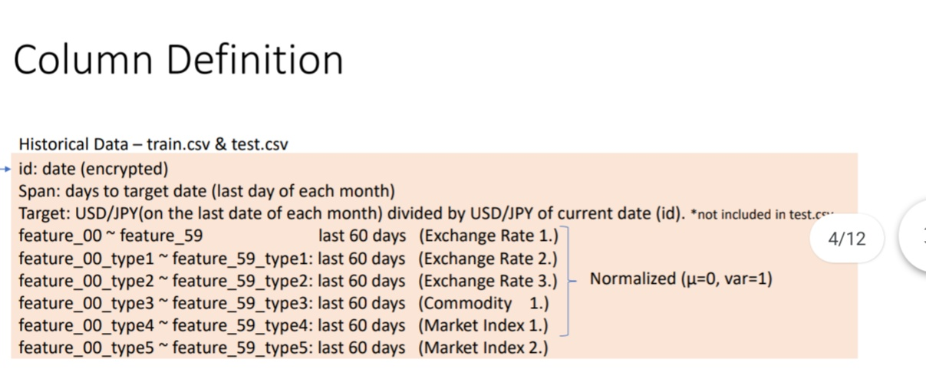
*PROBLEM STATEMENT:
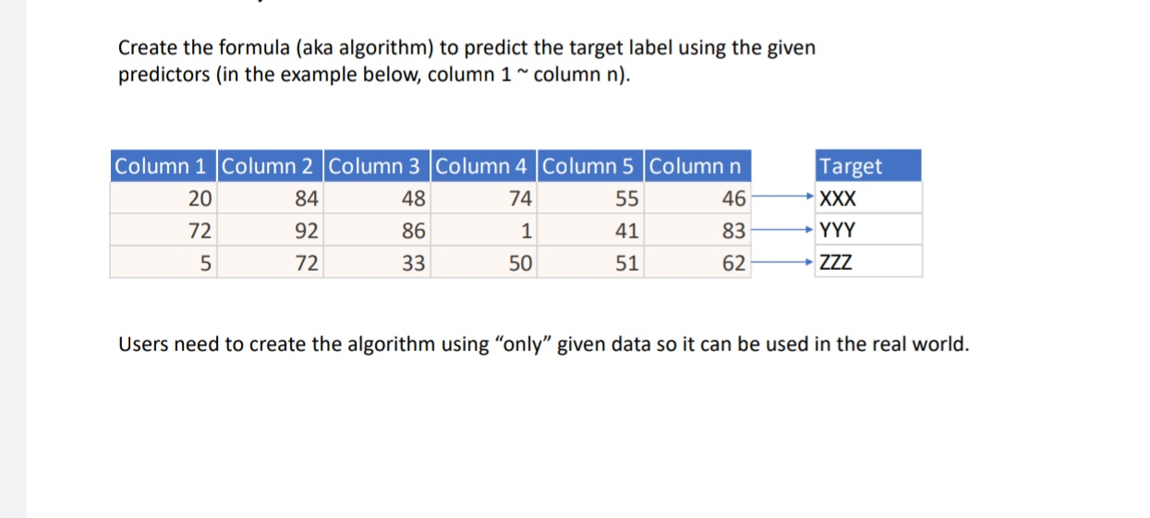
* EVALUATION CRITERIA:

